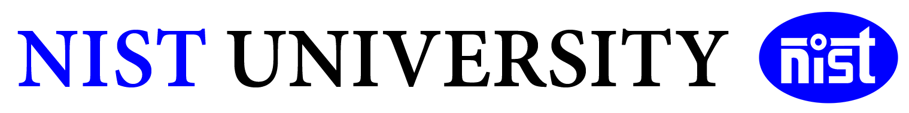
Academic Year: 2026
Subject- Aritificial Intelligence Tools
Code- CAI-200
Semester-4th Sem Batch- 2024-28 Section- D
Group Name-Code Crushers

Student Name | Roll Number
Maruti Nandan Dash | 202456482
Tusar Kant Swain | 202456485
G Srinibash | 202456402
Akhil Kumar | 202456486
Ankita Panigrahi | 202457422
Hrushikesh Pradhan | 202456364

Title of the Project-
AI CHATBOT FOR CAMPUS SERVICE

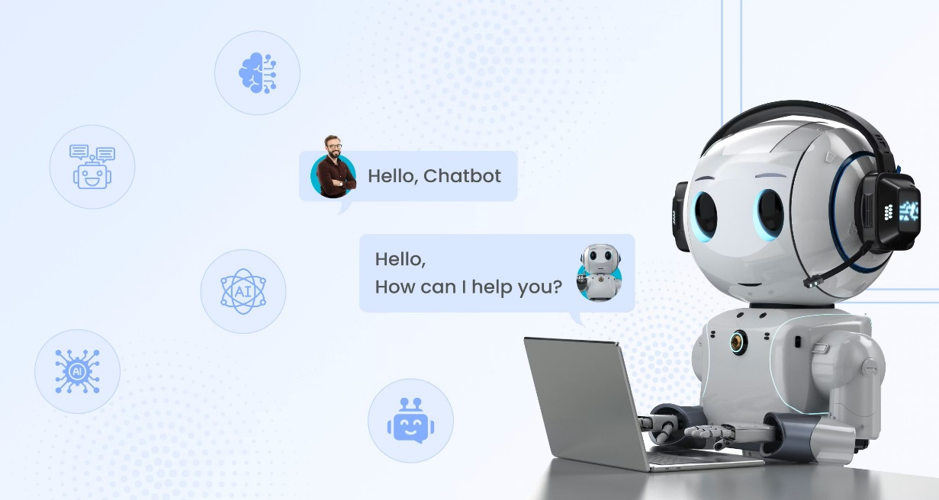

1.ABSTRACT
The AI Chatbot for campus services is an intelligent web-based system designed to automate responses to student queries related to admissions,fees,examinations,hostel facilities,and general campus information.The chatbot uses Natural Language Processing(NLP) through Dialogflow to understand user input and generate accurate responses in real time.
The system ensures 24/7 availability, reduces administrative workload, and improves accessibility of information for students. It is scalable, user-friendly, and can be integrated into institutional websites or mobile platforms.
To overcome these limitations, this project proposes the implementation of an AI-powered chatbot using Natural Language Processing (NLP) and machine learning techniques through Dialogflow. The chatbot is integrated with a web-based user interface developed using HTML, CSS, JavaScript, and Python Flask framework. The system understands user questions in natural language, identifies the appropriate intent, and provides accurate responses in real time.
The chatbot improves communication efficiency between students and the institution by offering 24/7 support and reducing administrative workload. It also enhances accessibility to campus information and provides a user-friendly digital solution for modern educational environments. The project demonstrates the practical application of Artificial Intelligence in automating campus services and improving student experience.

2.INTRODUCTION
Educational institutions handle a large volume of repetitive queries daily. Traditional methods such as visiting administrative offices, making phone calls, or browsing websites are inefficient and time-consuming.
With advancements in Artificial Intelligence (AI) and Natural Language Processing (NLP), chatbots have emerged as a powerful solution to automate communication.
This project develops a chatbot that:
1.Understands natural language queries
2.Provides instant responses
3.Enhances digital campus services
In today’s digital era, educational institutions are increasingly adopting modern technologies to improve communication, accessibility, and efficiency in campus management. Students frequently require information regarding admissions, fee payment, examination schedules, hostel facilities, scholarship details, and academic notifications. Traditionally, such information is obtained through administrative offices, notice boards, websites, or phone calls. However, these methods are often inefficient, time-consuming, and limited by office working hours.
Artificial Intelligence (AI) and Natural Language Processing (NLP) technologies have transformed the way organizations interact with users by introducing intelligent virtual assistants and chatbots. A chatbot is a software application designed to simulate human conversation and provide automated responses to user queries. AI chatbots are widely used in banking, healthcare, e-commerce, and customer support systems due to their ability to provide quick and accurate assistance.
The proposed AI Chatbot for Campus Services aims to automate student support services by developing an intelligent chatbot capable of answering campus-related questions instantly. The system uses Dialogflow for intent recognition and response generation, while Python Flask is used as the backend framework to connect the chatbot with a web interface.
The chatbot provides several advantages such as:
Continuous availability (24/7 support)
Faster response time
Reduced workload for administrative staff
Improved student satisfaction
Easy accessibility through web browsers
This project demonstrates how AI-based systems can modernize educational institutions and provide efficient digital campus services.

3.OBJECTIVES
1. To Provide Instant Responses
The chatbot is designed to provide immediate answers to frequently asked student queries such as admissions, fee details, hostel availability, examination schedules, and campus facilities.
2. To Reduce Administrative Workload
The system minimizes repetitive manual work for administrative staff by automating common student interactions and support services.
3. To Ensure 24/7 Availability
Unlike traditional office-based support systems, the chatbot remains available at all times, allowing students to access information whenever needed.
4. To Improve Student Experience
The chatbot offers a simple and interactive communication platform that improves accessibility and convenience for students.
5. To Implement AI and NLP Technologies
The project aims to demonstrate the practical implementation of AI and Natural Language Processing using Dialogflow in educational applications.
6. To Develop a Web-Based Chat Interface
The chatbot is integrated into a web application using HTML, CSS, JavaScript, and Python Flask to ensure ease of access through browsers.
7. To Create a Scalable System
The system is designed so that additional features such as voice interaction, multilingual support, and database integration can be added in the future.
8. To Promote Digital Transformation in Campus Services
The project supports the modernization of educational institutions by introducing AI-driven automated support systems.

4.PROBLEM STATEMENT
Students often face:
1.Delayed responses due to limited office hours
2.Difficulty finding accurate information
3.Dependency on manual support staff
Solution:
Develop an AI-powered chatbot that delivers real-time, automated responses using NLP.

5.SCOPE OF THE PROJECT
Included:
1.Admissions queries
2.Fee structure information
3.Exam schedules
4.Hostel information
Not Included:
1.Complex decision-making queries
2.Real-time database updates (optional future scope)

6.LITERATURE SURVEY
Existing systems include:
1.Static FAQ pages (limited interaction)
2.Email-based support (slow response)
3.Human-operated chat systems (costly)
AI chatbots using tools like Dialogflow and Rasa provide:
1.Faster responses
2.Better user interaction
3.Automation with scalability

7.WORKING PRINCIPLE
1.User enters a query in the chatbot interface
2.Request is sent to the Flask backend
3.Backend forwards request to Dialogflow
4.Dialogflow identifies intent
5.Appropriate response is generated
6.Response is displayed to the user

8.METHODOLOGY
Step 1: Data Collection
1.Gather FAQs from college website
2.Prepare question-answer pairs
Step 2: NLP Training
1.Create intents in Dialogflow
2.Add multiple variations of questions
Step 3: Backend Development
1.Flask API processes requests
2.Integrates with Dialogflow API
Step 4: Frontend Development
1.Chat UI using HTML, CSS, JavaScript
Step 5: Integration
1.Connect frontend → backend → AI engine

9.TECHNOLOGIES USED
LAYER TECHNOLOGY
1.Frontend 1.HTML,CSS,JAVAScript
2.Backend 2.Python
3.AI/NLP 3.Dialogflow
4.Alternative AI 4.Rasa
5.Database 5.SQLite/MySQL

10.IMPLEMENTATION DETAILS
1.Intents Created
- Admission
- Fees
- Hostel
- Exams
2.Example Training Data
- “How to apply?”
- Admission process?”
- What is fee structure?”
3.Backend Function
- API endpoint
- Handles POST requests
- Returns JSON response

11.RESULTS
1.Accurate responses for predefined queries.
2.Fast response time.
3.Improved user experience.

12.ADVANTAGES
1.Saves time
2.Reduces workload
3.Easy to use
4.Scalable system

13.LIMITATIONS
1.Limited understanding of complex queries.
2.Depends on training data quality.
3.Requires internet connection.

14.FUTURE ENHANCEMENTS
1.Multi-language support
2.Voice chatbot
3.Mobile app integration
4.Admin dashboard
5.Offline chatbot using Rasa

15.CONCLUSION
The project demonstrates the effective use of AI in automating campus services.The chatbot enhances communication,provides instant responses,and reduces manual workload.It can be further expanded into a full-scale campus assitant system.
The chatbot provides a modern and efficient solution by automating responses to frequently asked questions through a web-based interface. By integrating Dialogflow with the Python Flask framework, the system is capable of understanding natural language queries and generating appropriate responses in real time. This reduces dependency on manual administrative support and improves overall operational efficiency.
One of the major advantages of the system is its ability to provide 24/7 assistance, ensuring that students can access information anytime and from anywhere. The chatbot improves user experience by offering quick response times, simplified interaction, and easy accessibility through a browser-based platform. The implementation of AI technology in campus services also demonstrates how educational institutions can adopt digital transformation to improve communication and service management.
The project also highlights the importance of NLP in enabling machines to interpret human language effectively. Through intent recognition and trained datasets, the chatbot can respond accurately to predefined campus-related queries. The modular architecture of the system allows future scalability and integration of advanced features.

